Order Of Service

Singing: Psalm 33—CW page 79

Reading: Psalm 120

Opening Hymn: CW 496

Reading: Hebrews 11:8-16

Request Hymn: CW Supplement 754

Reading: Luke 15:1-10

Sermon Hymn: CW 363

Sermon Text: Song Of Solomon 1:4c

We Will Remember

Prayer

The Apostles’ Creed, TLH page 12

Holy Communion

The Lord's Prayer

The Blessing

Closing Hymn: CW 449

* * * * * * * * * * *

Bible Study: Lambs: Mark 10:17-31; Giving All To Jesus
Sheep: Proverbs 3:19-20
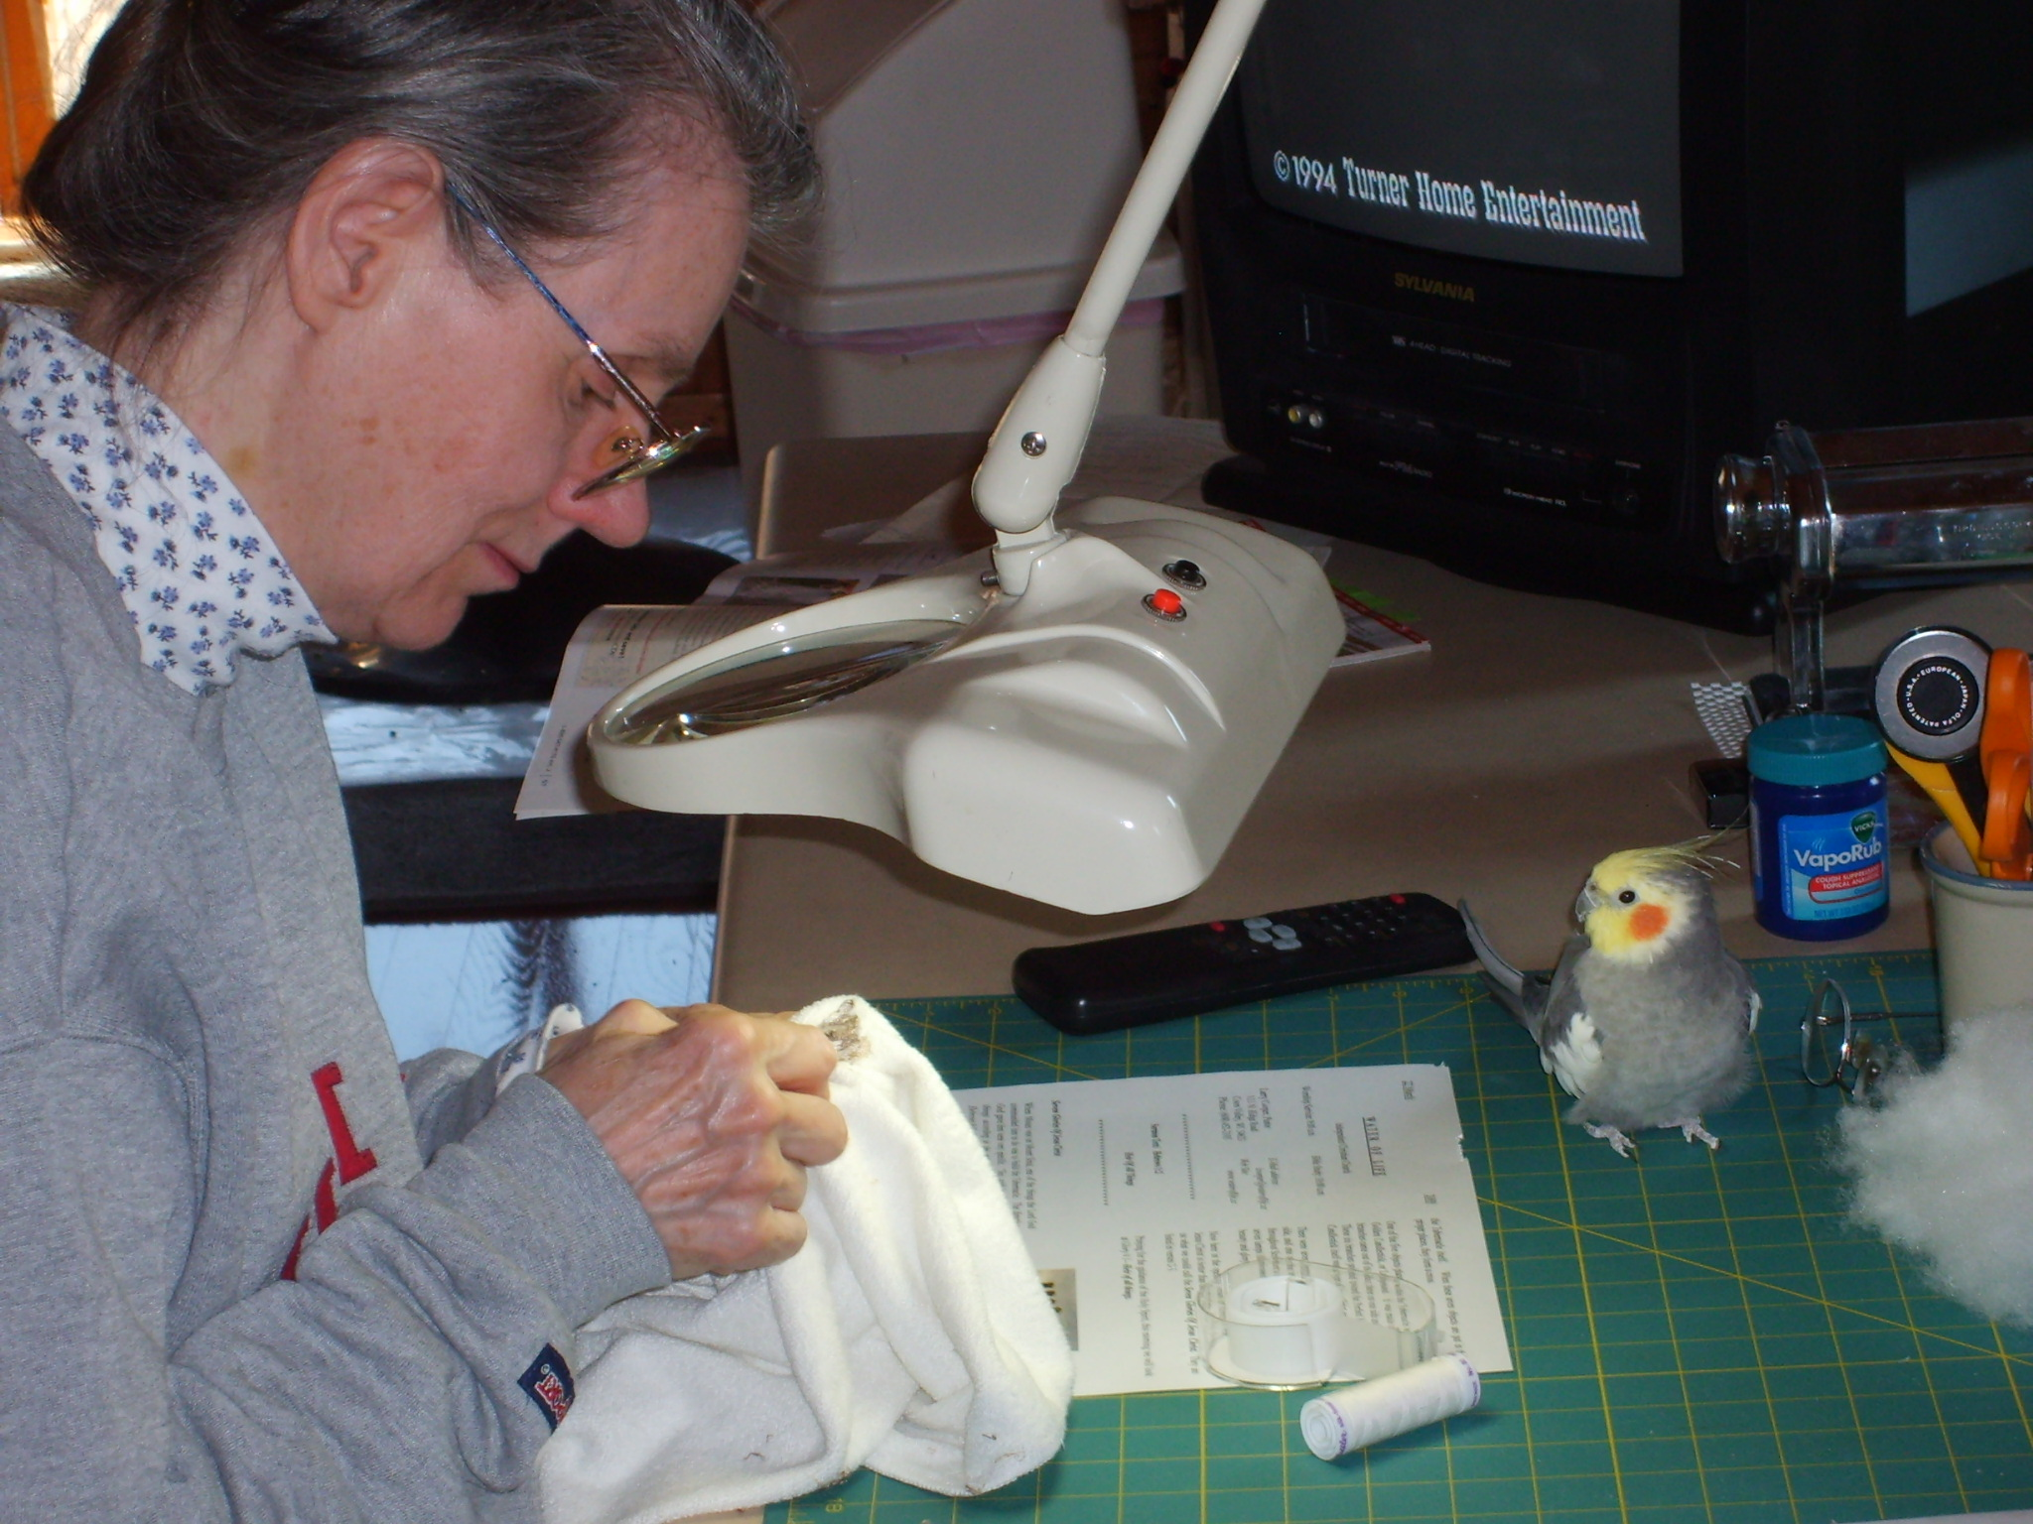

Need Any Help ???

Water
Of
Life

28 June 2015

W A T E R O F L I F E

Independent Christian Church—Conservative Lutheran Doctrine

Worship Service: 9:30 a.m. Bible Study: 10:45 a.m.

Larry Cooper, Pastor E-Mail address:
111 N. Ridge Road lcooper@wateroflife.cc
Coon Valley, WI 54623 Web Site:
Phone: (608) 452-2105 www.wateroflife.cc

* * * * * * * * * * * * * * * * * * * * * * * * * * *

Sermon Text: Song Of Solomon 1:4c

We Will Remember

* * * * * * * * * * * * * * * * * * * * * * * * * * *

4: Draw me, we will run after thee: the king hath brought me into his chambers: we will be glad and rejoice in thee, we will remember thy love more than wine: the upright love thee.

Memory is an amazing thing. But it can be either a blessing or a curse. It all depends.

If my computer is giving me the correct information, the word “remember” occurs 148 times in the KJV of the Holy Bible.
The Lord God has a memory. And there are many things that he will remember. But thankfully there are also some things which he promises he will not remember.

The children of the Devil also have memories. But there are many things that they forget in their lives on this earth. There are also some things that they will remember in the afterlife. Many of these things they will wish that they could forget. But they won’t be able to.

The elect children of God also have memories. And there are things which the Lord God commands us to remember. There are other things which, especially in the life to come, by the grace of God we will not remember.

We will take a look at some of these remembering passages in Scripture this morning.

